1. 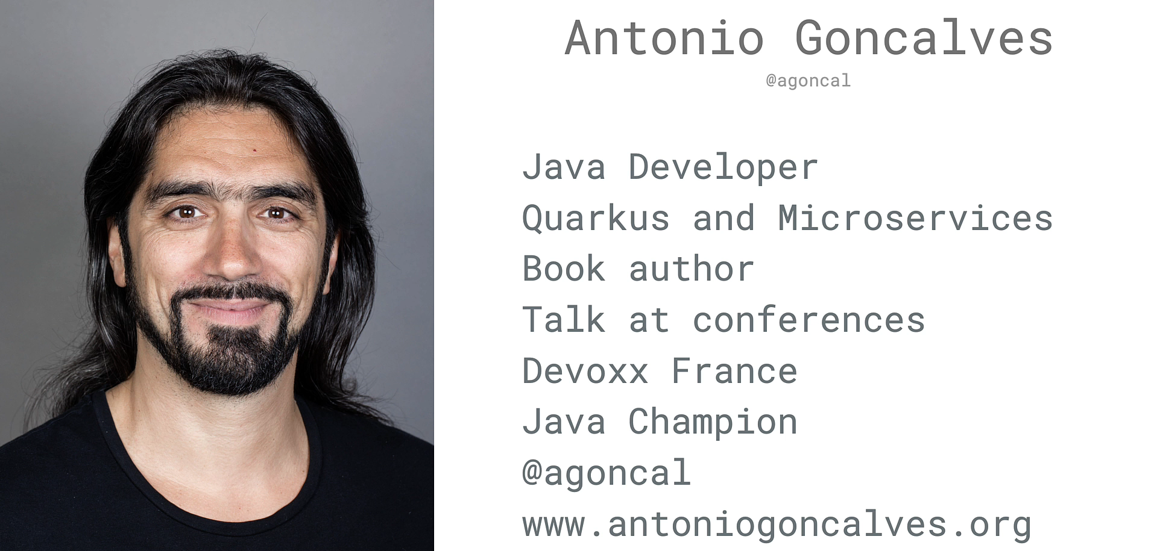
2. Shape

   Description automatically generated with low confidence
3. 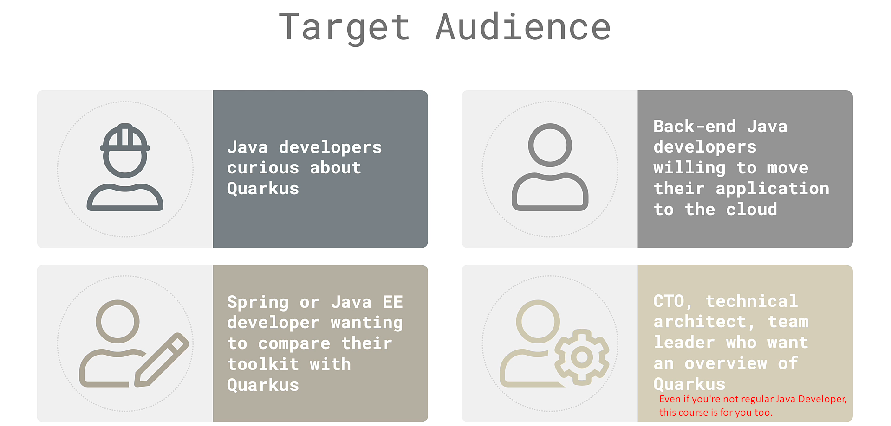
4. Text

   Description automatically generated
5. 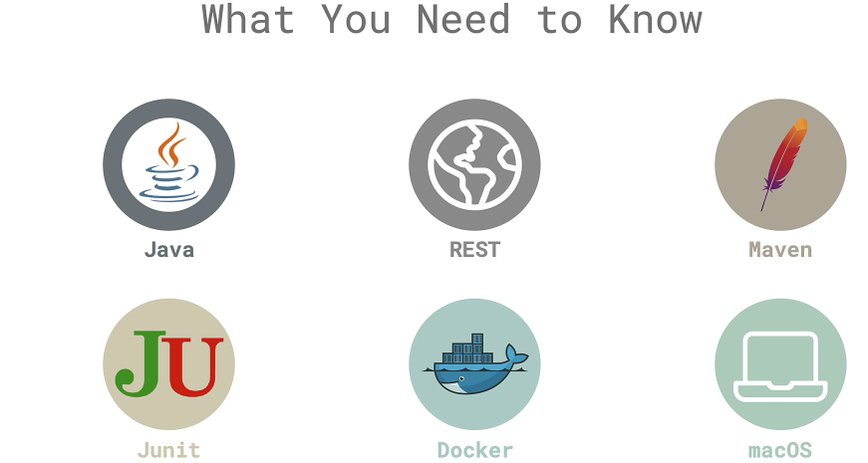
6. Graphical user interface, text, application

   Description automatically generated with medium confidence